***Abstract—***

***Introduction—*** Coastal estuaries exhibit variability in the seawater carbonate system, with implications for calcifying organisms. In particular, biochemical processing and river inflows alter total alkalinity (TA) conditions over small geographic scales (Hollarsmith 2019, Montagna et al 2018). Shifted conditions sometimes occur abruptly but can leave sessile calcifiers exposed for weeks to months. Given the extent to which external seawater conditions dictate performance for marine calcifiers, investigating how responses to such variation in TA change through time, especially when altered TA is combined with lower salinity, warrant deeper investigation.

Considerable research has documented disruptions in organism performance over short or long exposure periods, but few have attempted to document the degree to which net responses match incremental responses as a factor of exposure duration. Studies that have controlled explicitly for the influence of natural temporal variability have focused on understanding “when the exposure happens during vulnerable biological milestones” or how exposure to variable, fluctuations in conditions affects organisms differently than abrupt shifts to a new condition (cite). Oftentimes changes in conditions still result in suitable habitat, though, any shift in external chemical conditions burden osmoconformers with heightened energetic costs as they “conform”. As such, patterns between responses and seawater TA may vary through time as a function of physiological plasticity.

**How do shells and tissue growth differ when considering them as potential trade-offs?** Widely tolerable to extreme changes in seawater conditions, oysters have significant economic and ecological value to coastlines. As oysters grow naturally within reefs, they provide habitat for other estuarine species (cite), meanwhile, providing significant economic import for the commercial shellfish industry. As such, both shell growth and tissue growth, in particular as it relates to shell growth, must be considered. Juvenile species, although still pretty tolerant, often experience higher energetic costs to osmoconforming, resulting in well-documented trade-offs between shell and tissue growth.

Exploring the extent to which growth responses of oysters under altered TA conditions behave consistently through time is a natural expansion to prior work. Prior focus has demonstrated disrupted growth of many calcifiers by shifts in seawater carbonate conditions (cite), with substantial attention devoted to understanding the unique consequences of human-derived ocean acidification on marine molluscs (for review see Gazeau et al 2013). Others have demonstrated, whether or not intentionally, the consequences of low salinity in combination with diluted TA on oyster growth (cite), as laboratory seawater dilutions prepared with 0 TA distilled freshwater also dilute TA. Observed declines in growth can signify metabolic downregulation (cite) and an unmet increase in energetic demand (cite), which could result in trade-offs in shell or tissue growth (cite). What remains unexplored is how growth in oysters may change over time in response to variable TA conditions, both at ambient salinity and combined with low salinity.

Here we explore the incremental and net outcomes of different TA conditions on juvenile oyster growth. Specifically we X .

***Methods—***

**Study species—** The Eastern oyster, *Crassostrea virginica*, is native to subtidal reefs along eastern shores of North America (Gulf of St Lawrence to the Gulf of Mexico) (cite). Due to a wide salinity and thermal tolerance, however, *C. virginica* has been successfully introduced and is commercially grown on the west coast and in Hawaii (cite). We sourced juvenile oysters (size distribution) from a Hog Island Oyster Company in Tomales Bay, CA (coordinates) approximately 6 months after their arrival from X stock location. On 22 July 2022, oysters were transported in coolers (~60 min) to the UC-Davis Bodega Marine Laboratory (BML; Bodega Bay, CA), where they were acclimated in commercial grow bags to bubbled, flow-through seawater (at + X C) sourced from adjacent ocean waters (salinity ~ 34). Individuals were fed X% of their wet mass in algae every other day, using a mixed algal diet (SFD based on cell densities) recommended by growers (personal comm; cite?). Three days prior to the start of the experiment, we adhered the left valve to a X type plastic plate using X marine epoxy (n = 49 per plate, n = 12 plates).

Fig. 1

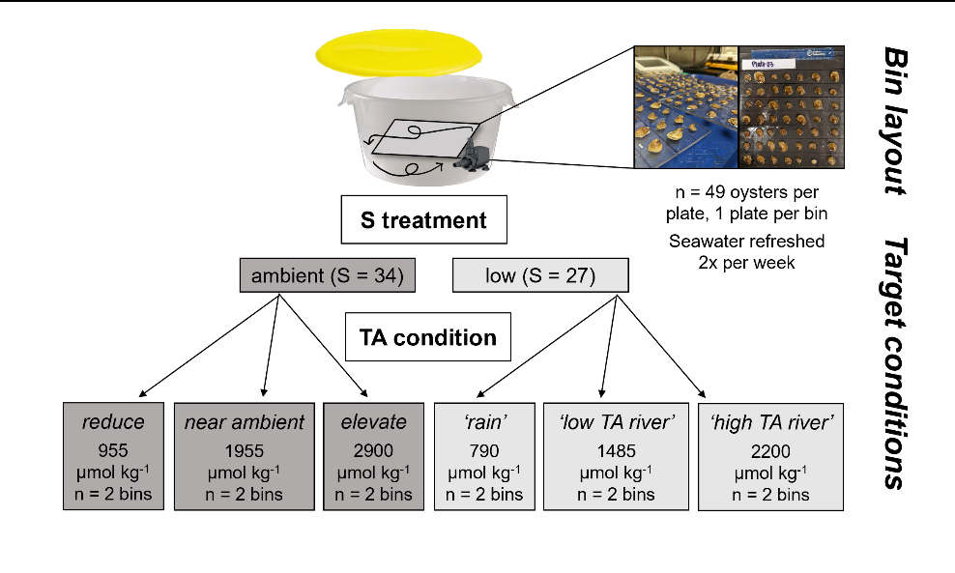

**Oyster growth experiment—** We held oysters in target TA and salinity conditions (see *Experimental conditions* below, Figure 1) for 5 weeks to quantify the effects of alkalinity and salinity on relative shell growth (surface area and thickness) and tissue mass (n = X total). We defined surface area growth rate as an increase in valve area (mm2) between t0 and tx, divided by the length of the interval (tx – t0; d-1) and shell thickness as the shell mass per area (mg/mm2). We quantified oyster surface area growth over three discrete increments (0-36 ‘net’, 0-18, 18-36 days) from ImageJ software (v.X) analysis of aerial photographs (with a scale bar) taken on three occasions (12.2 MP camera; day 0, 18, 36). Mortality of oysters was recorded at the same time as water changes, and dead shells were promptly discarded. We sacrificed all remaining live oysters on day 36, measuring shell mass separated from tissue mass and dried at 60C for 48-hr. We divided shell mass by surface area to compute shell thickness and tissue mass by shell mass to compute the biological condition index (cite).

**Experimental conditions—** Oysters were kept in isolated seawater of one of two salinity treatments coupled with one of three alkalinity conditions for 5 weeks (X; Figure X). We fed animals daily and primarily kept them in the dark (except for water change periods) to prevent shadows from disrupting activity (cite). Under ambient salinity treatments, oysters were exposed to reduced, near ambient (serving as a pseudo control) and elevated TA (mean TA = 1000 =-, 1950 +-, 2900 +- umol kg-1). TA conditions in low salinity treatments targeted the result of diluting ambient seawater (TA = 2250 umol kg -1, S = 34) with distilled freshwater (of low or high pCO2) or a river with TA near ambient (mean TA = 800 =-, 1500 +-, 2200 +- umol kg-1).

We performed complete seawater changes every third day to refresh targeted conditions (see *Chemical manipulation of seawater* below), at which time bins and recirculating pumps were thoroughly rinsed. Prior to and again after water changes, we measured experimental seawater temperature, salinity, pH voltage, and dissolved oxygen concentration with a handheld multi-parameter sonde (YSI X). Concurrently, we measured pH with spectrophotometric for half of the sonde measurements (calibrated daily with m-cresol dye standards, Easley and Byrne 2015), and used this relationship to translate all sonde pH voltage readings to total scale pH.

We determined seawater alkalinity by collecting and freezing 250ml seawater samples before and after water changes for later determination. We analyzed carbonate alkalinity concentration on a Metrohm 855 Titrosampler, where we corrected titration acid concentration daily with certified reference materials from the laboratory of Dr. Andrew Dickson (Scripps Institute of Oceanography).

We used measurements of seawater TA and pH, in combination with salinity and temperature to compute the full set of seawater carbonate system parameters employing the *seacarb* package in R (version 3.3.1). In our *seacarb* estimates, we used equilibrium constants determined for our salinity and temperature ranges (K1 and K2: Lueker et al. 2000, Kf: Perez and Fraga 1987, Ks: Dickson 1990). For simplicity, we will largely refer to the seawater carbonate system in terms of alkalinity, though we emphasize that additional parameters are required to fully describe seawater conditions (Table S1; see also Zeebe and Wolf-Gladrow 2001) and that these parameters could influence oyster growth independent of TA and pH (cite).

Experimental bins had lids but were not tightly sealed due to a gap created by the pump power cord, which may have had consequences for CO2 exchange and pH between water changes. Seawater temperature, salinity and TA exhibited similar variability over the course of the experiment, however, salinity and TA treatments remained independent (Figure 2). We saw declines of 0.4 pH units between water changes in control bins without oysters but negligible changes in seawater TA, indicating a slow uptake of atmospheric CO2 by experiment seawater. Continuous mixing with pumps ensured oxygen saturation remained high (> 80% cite), though, measurements from two bins did fall below 80% on two separate occasions due to pump motors failing (pumps were promptly replaced upon measurement).

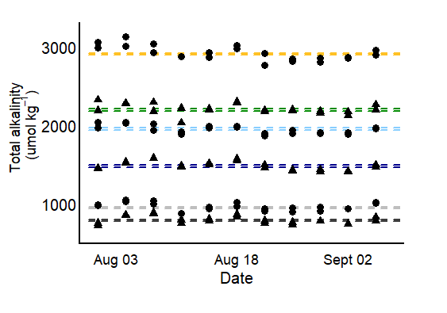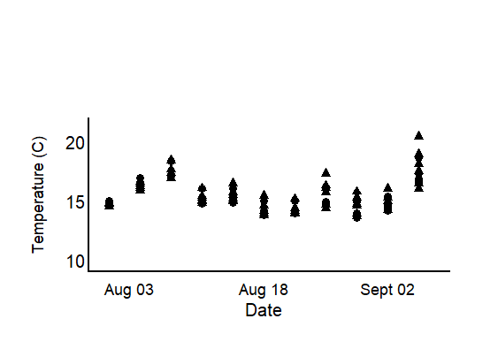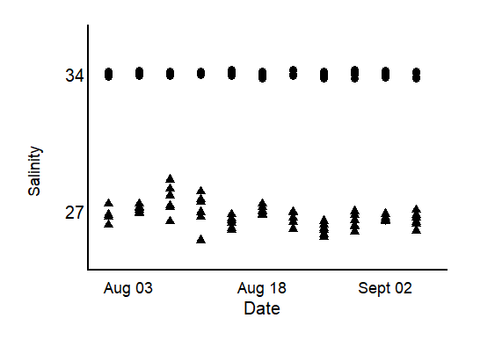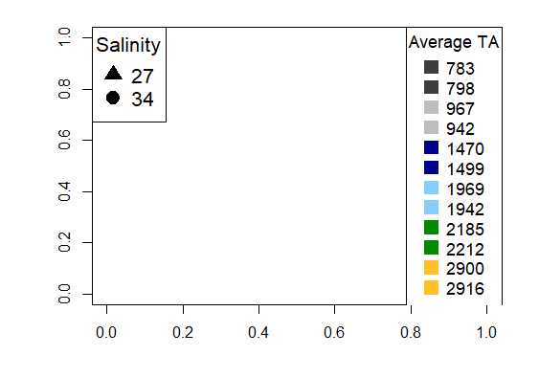

Fig. 2

**Chemical manipulation of seawater—**Every third day, we refreshed the carbonate system of the experimental seawater in each bin with a complete water change, as follows. Two days prior to each water change, we depleted seawater TA to negligible concentrations in large sumps (n = 4/ water change) by adding hydrochloric acid and strongly bubbling with ambient air. This method drove the carbonate system equilibrium reactions towards CO2, and allowed it to offgas out of seawater. We then mixed prepared seawater with distilled freshwater and adjusted the carbonate system back to desired TA (and high pH (> 7.8) using premade solutions of NaHCO3 (sodium bicarbonate) and Na2CO3 (sodium carbonate) with HCl (Waldbusser et al. 2015, Ninokawa et al. in review).

**Statistical analysis—**

***Exhibited responses to altered TA conditions after the first few weeks of exposure reflect overall patterns of net growth in estuarine oysters.***

***We detected a small effect of elevated TA on growth in both salinities after oysters had been exposed to conditions for longer periods (> 2.5 weeks). Only when coupled with lower salinity did we see an earlier effect of alkalinity conditions on average oyster growth.***

***Results—***

***Was the effect of SA.start***

***Incremental growth declined following exposure to conditions (which weakens overall impact of effects manifesting in the latter half of the experiment).***

**Incremental shell growth—**Oyster net growth was predominantly driven by growth occurring in the first experimental increment (0-18 days), as overall growth rates were significantly reduced in the second increment (18-36 days) (Figure x). Regardless, growth patterns changed, in the second incremental period suggesting that the effect of elevated TA, although weak, may strengthen the longer an oyster is exposed to high TA conditions (independent of salinity treatment). The effects of TA on incremental growth detected in the second experimental increment, though, contributes far less to overall growth patterns than the negligible effect of TA in the first increment.

We saw benefits of high TA on growth in low salinity conditions after the first experimental increment, whereas, the effect of TA was not detected in ambient salinity until the second increment. This may suggest that oysters were able to switch over their physio machinery to optimize growth in their preferred condition (lower S and high TA) more quickly than those in ambient salinity.

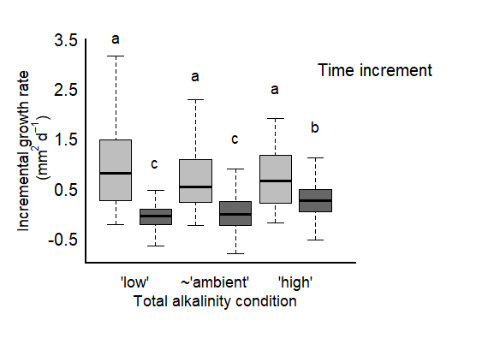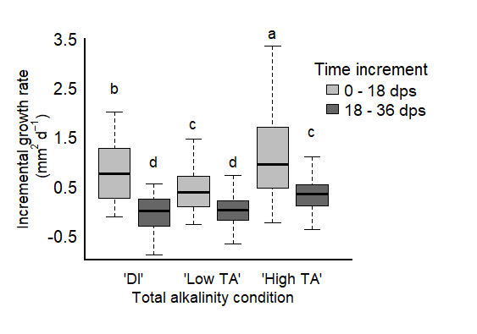

Fig. 5

***Focus on: the fact that shell growth was not impaired by low TA conditions in ambient salinity and that controlling for TA led to different net growth responses in low salinity conditions.***

**Net shell growth—**Responses to TA condition differed between the two salinity treatments. Combined with ambient salinity, TA condition did not have a significant effect on average net surface area shell growth (Table X, Fig. X). Low TA conditions corresponded to the saturation state of calcium carbonate frequently < 1 (S. Table X), indicating oysters in these conditions were experiencing seawater-driven dissolution. In contrast, ambient and elevated TA conditions fell well above the O precipitation threshold and therefore oysters in these conditions were void of saturation stress. With this in mind, a similar net shell growth rate across our treatments could occur if oysters in low TA conditions were able to biologically increase gross calcification to compensate for low-omega derived shell loss. Oysters in ambient and elevated TA conditions did not elevate net shell growth rates, however, WHY?.

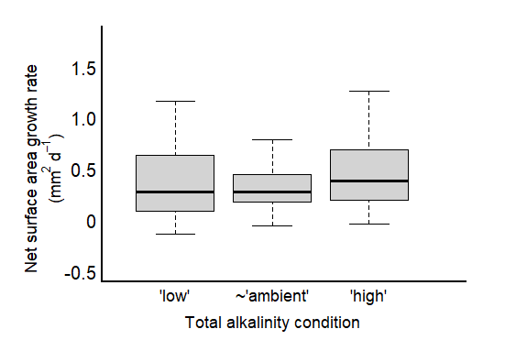

Fig. 3

In lower salinity, net surface area shell growth was highest in the highest TA condition (Fig. X). In low salinity conditions oyster net growth rates were X in two different TA conditions (X and X) that fell below and above CaCO3 saturation. Growth in both low S and TA conditions was significantly lower than in the ambient salinity, indicating that although shell loss from abiotic dissolution was compensated, oysters performed worse overall when low TA accompanied lower S, regardless of saturation state.

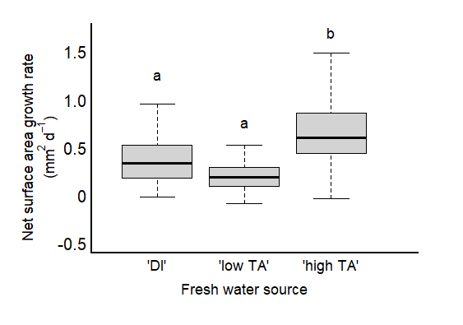

Fig. 4

Although we did not directly quantify seawater-driven shell loss, visible loss of organic periostracum material and underlying, external shell was apparent by day 18 of the experiment as a function of the CaCO3 calcite mineral form saturation state (Figure X). We did not detect a significant difference in the measured shell thickness, however, indicating that oysters were able to maintain similar shell mass per area (stats).

**Tissue growth and condition index—**Oysters maintained similar tissue mass, that was greater than average non-experiment oysters, in all salinity and TA conditions (stats). Further, oyster tissue mass to shell ratios were higher in all treatments than in non-experiment oysters, treatment conditions supplemented an improved biological condition. Oyster condition trended lower in X condition, though, the means didn’t differ statistically (stats). As tissue mass didn’t vary, this suggests differences in biological condition among oysters, were likely driven by differences in shell growth and not tissue mass.

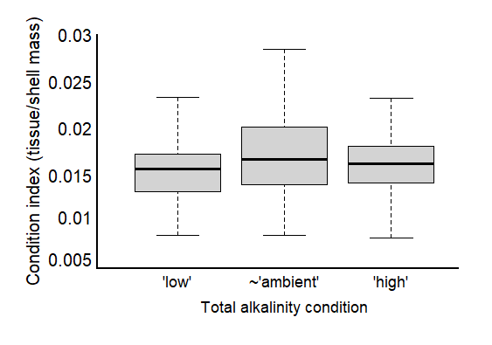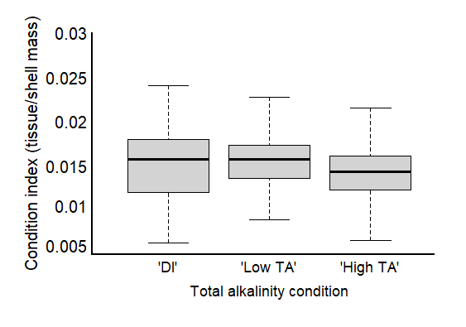

Fig. 6

Table X. Results of mixed effects, linear model testing the effects of starting size (mm2) and TA condition (factor) on (a) net surface area growth rates (mm2 d-1) and (b) shell mass per area in juvenile *Crassostrea virginica* oysters grown in **ambient** salinity. L-Ratios and p-values were recorded during backward stepwise model selection and refer to the ANOVA test output between the full model and a model with the specified predictor omitted. Bolded values denote a significant effect, determined by alpha < 0.05. The final models, Net growth rate ~ starting size + factor(TA condition) + RI(bin) + weight = by(TA condition) and Shell mass per area ~ starting size + factor(TA condition) + RI(bin) + weight = by(TA condition) accounted for ~ X and X% of the variation, respectively.

|  |  |  |  |  |  |  |
| --- | --- | --- | --- | --- | --- | --- |
| **Model A: Response- Net surface area growth rate (mm2 d-1)** | | | | | | |
| **Fixed Effects**  marg. r2 = 0.24  cond. r2 = 0.41 | **Estimate** | **Std. Error** | **t-value** | **df** | **L. Ratio** | **p-value** |
| Intercept (factor (low TA)) | 0.1241 | 0.0812 | 1.5284 | 228 | -- | 0.1278 |
| Starting size (mm2) | 0.0020 | 0.0003 | 6.1014 | 228 | 26.456 | **2.697e-07** |
| factor (mid TA) | -0.0860 | 0.0972 | -0.8852 | 3 | -- | 0.4412 |
| factor (elevated TA) | 0.0651 | 0.1013 | 0.6428 | 3 | -- | 0.5661 |
| **Random Effects** | **Intercept** | **Residual** |  |  | **L. Ratio** | **p-value** |
| Bin | 0.0889 | 0.1617 |  |  | 9.696349 | **0.0018** |

|  |  |  |  |  |  |  |
| --- | --- | --- | --- | --- | --- | --- |
| **Model B: Response- Shell mass per shell area (mg mm-2)** | | | | | | |
| **Fixed Effects**  marg. r2 = 0.02  cond. r2 = 0.02 | **Estimate** | **Std. Error** | **t-value** | **df** |  | **p-value** |
| Intercept (factor (low TA)) | 2.4990 | 0.0428 | 58.3549 | 229 |  | **< 0.0001** |
| factor (mid TA) | 0.1087 | 0.0709 | 1.5344 | 3 |  | 0.2225 |
| factor (elevated TA) | 0.2036 | 0.0877 | 2.3201 | 3 |  | 0.1031 |
| **Random Effects** | **Intercept** | **Residual** |  |  | **L. Ratio** | **p-value** |
| Bin | 2.1910e-05 | 0.5144 |  |  | 0.0067 | 0.9349 |

Table X. Results of mixed effects, linear model testing the effects of starting size (mm2) and salinity (factor) on net surface area growth rates (mm2 d-1) of juvenile *Crassostrea virginica* oysters grown in **near ambient TA conditions**. L-Ratios and p-values were recorded during backward stepwise model selection and refer to the ANOVA test output between the full model and a model with the specified predictor omitted. Bolded values denote a significant effect, determined by alpha < 0.05. The final model: Net growth rate ~ starting size + factor(TA condition) + RI(bin) + weight = by(TA condition), accounted for ~ X% of the variation).

|  |  |  |  |  |  |  |
| --- | --- | --- | --- | --- | --- | --- |
| **Response- Net surface area growth rate (mm2 d-1)** | | | | | | |
| **Fixed Effects**  marg. r2 = 0.62  cond. r2 = 0.63 | **Estimate** | **Std. Error** | **t-value** | **df** | **L. Ratio** | **p-value** |
| Intercept (factor(Samb)) | 0.0287 | 0.0554 | 0.5183 | 154 | -- | 0.6050 |
| Starting size (mm2) | 0.0021 | 0.0004 | 5.5668 | 154 | 21.0680 | 4.4320e-06 |
| Factor(Slow) | 0.3939 | 0.0538 | 7.3280 | 2 | -- | **0.0181** |
| **Random Effects** | **Intercept** | **Residual** |  |  | **L. Ratio** | **p-value** |
| Bin | 0.0256 | 0.1619 |  |  | 1.2933 | 0.2554 |

Table X. Results of mixed effects, linear model testing the effects of starting size (mm2) and TA condition (factor) on (a) net surface area growth rates (mm2 d-1) and (b) shell mass per area in juvenile *Crassostrea virginica* oysters grown in **low** salinity. L-Ratios and p-values were recorded during backward stepwise model selection and refer to the ANOVA test output between the full model and a model with the specified predictor omitted. Bolded values denote a significant effect, determined by alpha < 0.05. The final model: The final models, Net growth rate ~ starting size + factor(TA condition) + RI(bin) + weight = by(TA condition) and Shell mass per area ~ starting size + factor(TA condition) + RI(bin) + weight = by(TA condition) accounted for ~ X and X% of the variation, respectively. We tested for differences in the TA conditions by looking for overlap in confidence intervals given by the model and are labeled as such.

|  |  |  |  |  |  |  |
| --- | --- | --- | --- | --- | --- | --- |
| **Model A: Response- Net surface area growth rate (mm2 d-1)** | | | | | | |
| **Fixed Effects**  marg. r2 = 0.45  cond. r2 = 0.54 | **Estimate** | **Std. Error** | **t-value** | **df** | **L. Ratio** | **p-value** |
| Intercept (factor (low TA)) | 0.0728 | 0.0560 | 1.3002 | 218 | -- | 0.1949 |
| Starting size (mm2) | 0.0021 | 0.0003 | 6.3366 | 218 | 30.2850 | **3.729e-08** |
| factor (mid TA) | -0.1405 | 0.0434 | -3.2410 | 3 | -- | **0.0478** |
| factor (elevated TA) | 0.3460 | 0.0594 | 5.8282 | 3 | -- | **0.0101** |
| **Random Effects** | **Intercept** | **Residual** |  |  | **L. Ratio** | **p-value** |
| Bin | 0.0316 | 0.2018 |  |  | 0.1830 | 1.7731 |

|  |  |  |  |  |  |  |
| --- | --- | --- | --- | --- | --- | --- |
| **Model B: Response- Shell mass per shell area (mg mm-2)** | | | | | | |
| **Fixed Effects**  marg. r2 = 0.02  cond. r2 = 0.02 | **Estimate** | **Std. Error** | **t-value** | **df** |  | **p-value** |
| Intercept (factor (low TA)) | 2.5936 | 0.0500 | 51.8338 | 291 |  | **<0.001** |
| factor (mid TA) | 0.0161 | 0.0625 | 0.2581 | 3 |  | 0.8130 |
| factor (elevated TA) | -0.0396 | 0.0611 | -0.6485 | 3 |  | 0.5629 |
| **Random Effects** | **Intercept** | **Residual** |  |  | **L. Ratio** | **p-value** |
| Bin | 1.7423e-05 | 0.4156 |  |  | 7.6766e-08 | 0.9998 |

Table X. Results of mixed effects, linear model testing the effects of factor(TA condition) and factor(experimental increment) on incremental surface area growth rates (mm2 d-1) in juvenile *Crassostrea virginica* oysters grown in **ambient or low salinity**. Change in surface area is relative to the size of the oyster at the beginning of the experimental increment (initial (0-18) or at day 18 (18-36). L-Ratios and p-values were recorded during backward stepwise model selection and refer to the ANOVA test output between the full model and a model with the specified predictor omitted. Bolded values denote a significant effect, determined by alpha < 0.05. The final model: Incremental growth rate ~ factor(TA condition) + factor(experimental increment) + RI(bin) + weight = by(TA condition), accounted for ~ X% of the variation.

|  |  |  |  |  |  |  |
| --- | --- | --- | --- | --- | --- | --- |
| **Model A: Response- Incremental surface area growth rate (mm2 d-1) ambient salinity** | | | | | | |
| **Fixed Effects**  marg. r2 = 0.62  cond. r2 = 0.63 | **Estimate** | **Std. Error** | **t-value** | **df** |  | **p-value** |
| Intercept (factor (increment 0-18)) | 0.7292 | 0.1476 | 4.9401 | 437 |  | < 0.0001 |
| factor(TA condition) | -4.990e-05 | 6.7690e-05 | -0.7368 | 4 |  | 0.5021 |
| factor (increment 18 -36) | -1.0384 | 0.1172 | -8.8637 | 437 |  | < 0.0001 |
| TA:increment | 0.0002 | 5.2910e-05 | 4.0534 | 437 |  | 0.0001 |
| **Random Effects** | **Intercept** | **Residual** |  |  | **L. Ratio** | **p-value** |
| Bin | 0.1113 | 0.5675 |  |  | 9.6472 | 0.0019 |

|  |  |  |  |  |  |  |
| --- | --- | --- | --- | --- | --- | --- |
| **Model A: Response- Incremental surface area growth rate (mm2 d-1) low salinity** | | | | | | |
| **Fixed Effects**  marg. r2 = 0.31  cond. r2 = 0.35 | **Estimate** | **Std. Error** | **t-value** | **df** |  | **p-value** |
| Intercept (factor (increment 0-18)) | 0.5446 | 0.1337 | 4.0747 | 411 |  | **0.0001** |
| factor(TA condition) | 2.6900e-05 | 6.2130e-05 | 0.4335 | 4 |  | 0.6870 |
| factor (increment 18 -36) | -0.8323 | 0.1055 | -7.8870 | 411 |  | **< 0.0001** |
| TA:increment | 0.0002 | 4.8990e-05 | 3.3896 | 411 |  | **0.0008** |
| **Random Effects** | **Intercept** | **Residual** |  |  | **L. Ratio** | **p-value** |
| Bin |  |  |  |  | 10.9906 | <0.0001 |

Table X. Results of mixed effects, linear model testing the effects of treatment condition (factor) on (a) average tissue mass (mg) and (b) average condition index (tissue mass per shell mass) in juvenile *Crassostrea virginica* oysters. Bolded values denote a significant effect, determined by alpha < 0.05. The final models, Tissue mass ~ factor(treatment) + RI(bin) and Condition index ~ factor(treatment) + RI(bin) We tested for differences in the across treatment conditions by looking for overlap in confidence intervals given by the model and are labeled as such.

|  |  |  |  |  |  |  |
| --- | --- | --- | --- | --- | --- | --- |
| **Model A: Response- Tissue mass (mg)** | | | | | | |
| **Fixed Effects** | **Estimate** | **Std. Error** | **t-value** | **df** |  | **p-value** |
| Intercept (lowS,lowTA) | 5.8010 | 0.4353 | 13.3267 | 448 |  | **< 0.0001** |
| factor(ambS,lowTA) | -0.6765 | 0.6078 | -1.1131 | 6 |  | 0.3083 |
| factor(lowS,midTA) | 0.0743 | 0.6001 | 0.1238 | 6 |  | 0.9055 |
| factor(ambS,midTA) | 0.8077 | 0.5972 | 1.3524 | 6 |  | 0.2250 |
| factor(lowS,highTA) | -0.2245 | 0.6045 | -0.3714 | 6 |  | 0.7231 |
| factor(ambS,highTA) | 0.5032 | 0.6017 | 0.8362 | 6 |  | 0.4351 |
| **Random Effects** | **Intercept** | **Residual** |  |  | **L. Ratio** | **p-value** |
| Bin | 0.3837 | 2.7849 |  |  | 10.9906 | <0.0001 |

|  |  |  |  |  |  |  |
| --- | --- | --- | --- | --- | --- | --- |
| **Model B: Response- Condition index (tissue mass (mg) per shell mass (mg))** | | | | | | |
| **Fixed Effects** | **Estimate** | **Std. Error** | **t-value** | **df** |  | **p-value** |
| Intercept (lowS,lowTA) | 5.8010 | 0.4353 | 13.3267 | 448 |  | **< 0.001** |
| factor(ambS,lowTA) | -0.6766 | 0.6078 | -1.1307 | 6 |  | 0.3083 |
| factor(lowS,midTA) | 0.0743 | 0.6001 | 0.1238 | 6 |  | 0.9055 |
| factor(ambS,midTA) | 0.8077 | 0.5972 | 1.3524 | 6 |  | 0.2250 |
| factor(lowS,highTA) | -0.2245 | 0.6045 | -0.3714 | 6 |  | 0.7231 |
| factor(ambS,highTA) | 0.5032 | 0.6017 | 0.8362 | 6 |  | 0.4351 |
| **Random Effects** | **Intercept** | **Residual** |  |  | **L. Ratio** | **p-value** |
| Bin |  |  |  |  | 29.9117 | **< 0.0001** |

***Discussion—***